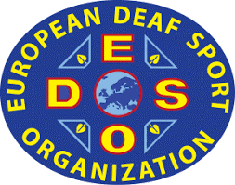 | 1st EUROPEAN DEAF MIXED DOUBLES  CURLING CHAMPIONSHIPS  18 November – 21 November 2021  ŁÓDŹ, Poland | 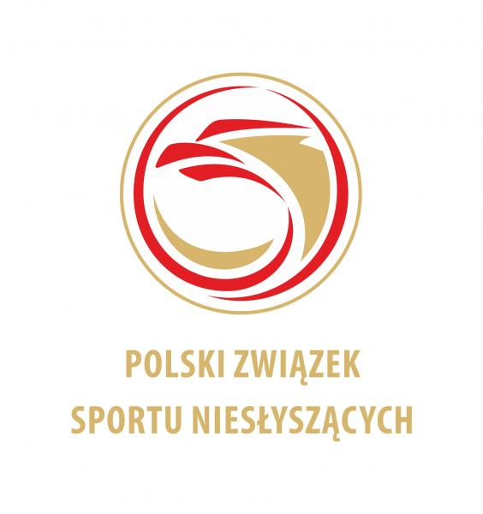
TRAVEL INFORMATION

COUNTRY
NAME OF FEDERATION
NUMBER OF PERSON
CONTACT PERSON
EMAIL ADRES

ARRIVAL
TO WARSAW AIRPORT
DATE | TIME | AIRLINE | FLIGHT NUMBER

BUS or TRAIN
DATE | TIME

DEPARTURE
FROM WARSAW AIRPORT
DATE | TIME | AIRLINE | FLIGHT NUMBER

BUS or TRAIN
DATE | TIME

Comments:
What's the problem then please write

Please send this form by e-mail to info@pzsn.pl but not later than 18 October 2021
Date: | President or Secretary:

